Bank Loan Model

Dependent variable = personal loan

Independent variable = Age, Experience, Income, Family, CCAvg, Education, Mortgage, Securities Account, CD Account, Online, Credit Card

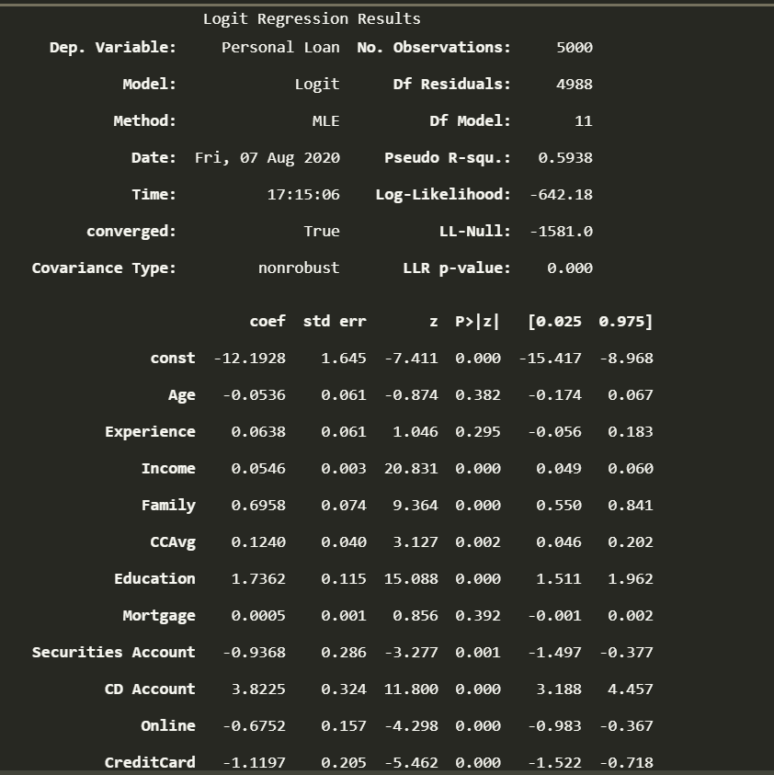Result of Logistic regression:

Remark:

According to result of logistic regression all independent variables are significantly important. Out of all **Income, Family, CCAvg, Education, Securities Account, CD Account, Online, Credit Card** are most significantly important variables.

Attrition Model

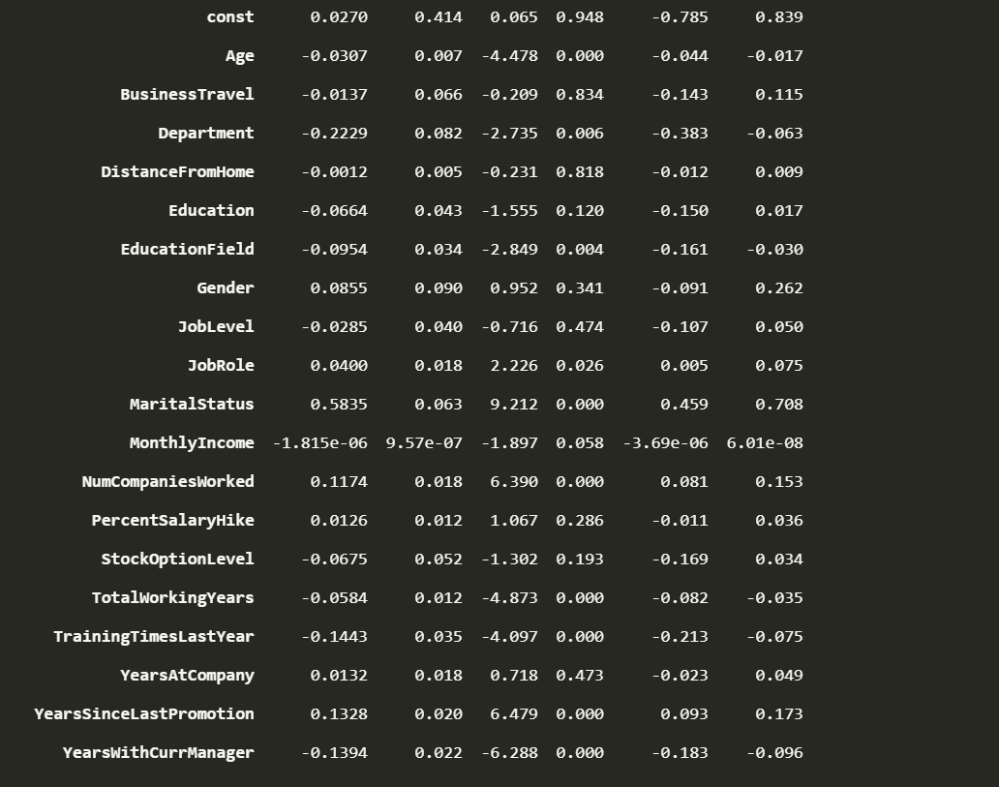According to the regression result, out of all variables BusinessTravel, DistancefromHome, Education, Gender, JobLevel, PercentSalaryHike, YearsAtCompany are least significant variables.

And **Age, Department, EducationField, MaritalStatus, NumCompaniesWorked , TotalworkingYears, TrainingTimesLastYear, YearSinceLastPromotion , YearwithCurrManager** are most significant variables.